**Project Specification Document**

NICTA

Ted Friedman

Eric Krenz

Sean Luthjohn

Jordan Steffan

**Table of Contents**

Section Page

Table of Contents

1. Project Vision and Objectives………………………………………………………………..4

1.1 Project Scope and Vision 4

1.2 Project Goals and Objectives 4

2. Project Planning……………………………………………………………………………... 5

2.1 Project Lifecycle 5

2.2 Project Setup 5

2.3 Stakeholders 5

2.4 Project Resources 6

2.5 Assumptions 6

2.6 Estimates 6

3. Project Tracking…………………………………………………………………………….. 7

3.1 Tracking 7

3.2 Communication Plan 7

Regularly Scheduled Meetings 7

Information To Be Shared Within Our Group 7

Information To Be Provided To Other Groups……………………………........................... 8

Information Needed From Other Groups 8

3.3 Deliverables 8

3.4 Project Metrics 9

4. Requirements………………………………………………………………………………. 10

4.1 Overall Description 10

4.2 Users and Roles 10

4.3 Use Case Diagrams 11

4.4 High-Level Requirements 11

4.5 Low-Level Requirements 12

4.6 Constraints and Limitations 12

5. Design………………………………………………………………………........................ 13

5.1 Introduction 13

5.2 Scope 13

5.3 High-Level Component Design 13

5.4 Activity Diagrams 15

5.5 Class Diagram 16

5.6 Sequence Diagram 16

5.7 Data Architecture 16

5.8 Alternative Designs and Design Rationale 16

6. User Interface………………………………………………………………………………. 17

6.1 UI Description 18

6.2 UI Mockup 18

7. Test Plan……………………………………………………………………………………. 19

7.1 Test Plan Description 19

7.2 Testing Tools 19

7.3 Test Data 19

7.4 Test Types and Frequency 19

7.5 Test Coverage 19

7.6 Test Location 20

8. Project Closure……………………………………………………………………………... 21

8.1 Goals / Vision 21

8.2 Delivered Solution 21

8.3 Remaining Work 21

9. Deliverables………………………………………………………………………………... 22

9.1 Study Results 22

9.2 Requirements and Design Documents 22

9.3 Code 22

9.4 Tests and Test Results 22

9.5 Build Process Documents 22

9.6 Install Process Documents 22

9.7 Administrator’s and/or User’s Manual 22

9.8 Postmortem Document 22

9.9 Final Report 22

10. Definitions and Acronym……………………………………………………………….. 23

**1. Project Vision and Objectives**

**1.1 Project Scope and Vision**

Scope - We will format travel data, such as purpose of commute and type of transportation used, provided by NICTA to be displayed on the Australian National Map by utilizing QGIS.

Vision - Various users will be able to input additional travel data via a CSV file in the formats of the data supplied to us by NICTA and have it automatically usable and displayed by the Australian National Map.

**1.2 Project Goals and Objectives**

|  |  |
| --- | --- |
| **#** | **Goal or Objective** |
| 1 | Provide full documentation on our plans for, progress on, completion of, and how to use our system. |
| 2 | Build a system which can automatically format the first set of data for the national map. |
| 3 | Make this system easy to use and presentable as a prototype in time for midterm presentations. |
| 4 | Improve the system to make it automatically format the second set of data, and all future data, to be usable for the national map |
| 5 | Within time constraints, come up with new and creative ways for visualization of the formatted data on the national map. |
| 6 | Present final deliverables and documentation to NICTA and for our Capstone |

**2. Project Planning**

**2.1 Project Lifecycle**

For our project our team will use an agile approach. We have met with our sponsor to gather requirements and are creating a high level development plan that accounts for them. We have three large requirements which will be broken down and outlined in our project plan. We will then follow an approach based on frequent group meetings and communication while developing a system to meet the requirements.

**2.2 Project Setup**

|  |  |
| --- | --- |
| **#** | **Decision Description** |
| 1 | Travel data from Australian government in the form of a CSV |
| 2 | Standards that must be followed include the default Capstone coding standard. |
| 3 | Special access privileges needed, nondisclosure forms, must be taken care of. |
| 4 | Web server for testing environment |
| 5 | Fork of National Map for development |
| 6 | Github for project documents and data used. Accessible by group, professor, sponsor, mentor, and teaching assistant, |
| 7 | Group decision to use Google Drive for collaborative work on documents. Documents will be moved to Github, when completed. |

**2.3 Stakeholders**

|  |  |
| --- | --- |
| **Stakeholder** | **Role** |
| John Grundy | Sponsor |
| Iman Avazpour | Mentor |
| Dean Knudson | Instructor |
| Sean Luthjohn | Team member |
| Jordan Steffan | Team member |
| Eric Krenz | Team member |
| Ted Friedman | Team member |

**2.4 Project Resources**

|  |  |
| --- | --- |
| **Resource** | **Resource Description** |
| Team Github Repository | Will be used to store our project documents and data. |
| Capstone Team | Our team of students who will be the primary developers of the project. |
| Iman Avazpour | The mentor who will be able to provide us with technical assistance. |
| Google Drive | Collaborative work on project documents, which when completed will be moved to Github. |
| NICTA Repository | The code and information on the National map of Australia. We will use this to try and integrate the data into the map. |
| <http://visual.bts.nsw.gov.au/lga/> | Initial project data, provided to us by our project mentor. Data will be integrated into the National Map System. |
| Cesium | Javascript API that was used to make the National map. Will be helpful in learning how the map works and the code involved in making it. |
| John Grundy | The sponsor who will be able to provide us with some guidance and help with the project as we work. |

**2.5 Assumptions**

|  |  |
| --- | --- |
| **#** | **Assumption** |
| A1 | The sample data will be continuously delivered as we need it |
| A2 | The group will be able to continuously meet and make progress |
| A3 | The group will have continuous access to computers with Microsoft Project |
| A4 | We will be allowed access to all of the necessary data on the country |

**2.6 Estimates**

|  |  |  |
| --- | --- | --- |
| **Metric** | **Estimated Value** | **Actual Value** |
| Hours | 300 hours |  |
| Lines of Code | 1000 lines |  |
| Manual / Help Document Pages | 6 pages |  |
| Unit Tests | 75 tests |  |

**3. Project Tracking**

**3.1 Tracking**

|  |  |  |
| --- | --- | --- |
| **Information** | **Description** | **Link** |
| Code Storage | Project code will be stored on Github. | [Link](https://github.com/Fedoraman42/NICTA-NDSU-National-Map) |
| User Stories | HuBoard will be used for managing user stories and progress made on them. | [Link](https://huboard.com/Fedoraman42/NICTA-NDSU-National-Map/) |
| Continuous Integration | Will be added as necessary | N/A |
| Regression Testing | Will be added as necessary | N/A |
| Data Storage | Project data, and documents will be stored on Github | [Link](https://github.com/Fedoraman42/NICTA-NDSU-National-Map) |
| Sensitive Data Storage | Sensitive data will be stored on an encrypted Github by NICTA | N/A |
| Collaborative Work | Work on documents will be done on Google drive and then moved to Github upon completion. | [Link](https://drive.google.com/folderview?id=0B67oYcpJpbAnRUw5ajhsalRlUW8&usp=sharing) |

**3.2 Communication Plan**

**Regularly Scheduled Meetings**

|  |  |  |
| --- | --- | --- |
| **Meeting Type** | **Frequency/Schedule** | **Who Attends** |
| Conference Call | Weekly | Project team and mentor, possibly sponsor |
| Team Meeting | Twice a week & as needed | Project team |
| Short Meeting | Weekly before class | Project team |
| Sprint Planning Meeting | Start of each sprint | Project team and mentor |
| Sprint Retrospective Meeting | End of each sprint | Project team |
| Sprint Review Meeting | End of each sprint | Project team, mentor, and sponsor |

**Information To Be Shared Within Our Group**

|  |  |  |  |
| --- | --- | --- | --- |
| **Who?** | **What Information?** | **When?** | **How?** |
| Project team | Task assignments | At team meetings & as needed | Team meetings, listing in MS Project file. |
| Project team | Australian Data | When necessary as per development | Email, Github |
| Project team, mentor | Project Plan | At the beginning of each spring | Email, Skype, Github |

**Information To Be Provided To Other Groups**

|  |  |  |  |
| --- | --- | --- | --- |
| **Who?** | **What Information?** | **When?** | **How?** |
| Sponsor and mentor | Final report | At completion of project | Req./Design docs., code, Power Point presentation |
| Sponsor and mentor | Project baselines | At the end of each sprint | Onsite customer demo, access to repository |
| Sponsor and mentor | Weekly report | Weekly | Email and Trac site access |

**Information Needed From Other Groups**

|  |  |  |  |
| --- | --- | --- | --- |
| **Who?** | **What Information?** | **When?** | **How?** |
| Sponsor and mentor | Requirement changes | Start of each sprint | Conference call or meeting with sponsor and mentor. |
| Mentor | Australian Travel Data | As necessary | email, git or conference call |

**3.3 Deliverables**

|  |  |  |  |
| --- | --- | --- | --- |
| **#** | **Deliverable** | **Delivery Time** | |
| **Interim** | **Final** |
| 1 | Prototype Code | ▢ |  |
| 2 | Documentation on Prototype |  | ▢ |
| 3 | Prototype for Secondary Set of Data | ▢ |  |
| 4 | Documentation on Second Prototype |  | ▢ |
| 5 | Possible Adjustments to National Map for New Visualization Methods | ▢ |  |
| 6 | Final Documentation | ▢ |  |
| 7 | Finished Project | ▢ |  |

**3.4 Project Metrics**

|  |  |  |
| --- | --- | --- |
| **Metric** | **Frequency** | **Location** |
| Estimated User Stories | Per user story as set in the project plan with readjustment at the start of each sprint | MS Project Plan |
| Actual User Stories | Per user story to reflect actual work and time put into each user story | MS Project Plan |
| Estimated Sprint User Stories | At the start of each sprint based on past abilities | MS Project Plan |
| Actual Sprint User Stories | At the end of each sprint | MS Project Plan |

**4. Requirements**

**4.1 Overall Description**

Our project’s purpose is to help make mobility data easily accessible to the Australian public through National Map. To that end, we were given the task of making National Map capable of reading data from any format, a task that has broken into a simple two-step process. As of right now, National Map reads data that is formatted in a specific way; specifically, input data must contain latitude and longitude coordinates.

For the first step, we were given a sample dataset to work with. This sample data does not have latitude and longitude coordinates included. As such, we will have to find a way to make this data compatible with National Map during the first step of the project.

Once that is completed, we’ll move on to step two, where we’ll be given a second sample dataset to integrate into what we have working from step one. However, this new dataset will have some differences to it, making the problem of making it just as compatible with National Map as the first data set non-trivial. As a team, we have decided that as we can, we will keep this in mind and attempt to make the main task for step two as painless as possible as we work on step one.

**4.2 Users and Roles**

|  |  |
| --- | --- |
| **User** | **Description** |
| Public User | A regular user who can access data on the national map as well as input their own data onto the map provided it is formatted correctly. |
| Admin | A user who can make changes to how the National Map works along with utilizing the map like a Public User. |

**4.3 Use Case Diagrams**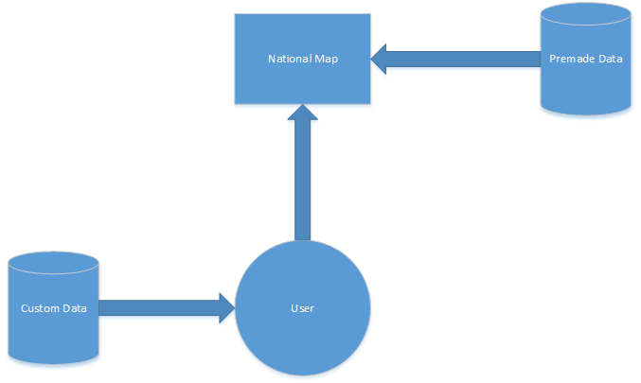

**4.4 High-Level Requirements**

5 Complexity Points Standard -- Fully analyze the ethics, stakeholders, and implications behind an ethical dilemma in the computer science world.

|  |  |  |  |  |
| --- | --- | --- | --- | --- |
| **ID** | **Added** | **Description** | **Status** | **Story Points** |
| 100 | Onset | As a user, I want to easily access mobility data for all LGA’s in New South Wales to gain knowledge about the best ways to plan my transportation. | **C** | **52** |
| 200 | Onset | As a user, I want to be able to view the mobility data in a web browser for easy access. | **C** | **13** |
| 300 | Onset | As a user, I want to specify what data to visualize and how to visualize it so I can access the data I want while having vast amounts of data available if I need. | **C** | **13** |
| 400 | Onset | As a user, I want access to the mobility data from more than just New South Wales if I live somewhere else in Australia. | **C** | **TBD** |
| 500 | Onset | As a user, I want to be able to compare and visualize data in different ways to aid in understanding it | **T** | **TBD** |
| 600 | Sprint 2 | As an admin, I want to be able to potentially add new data layouts in the future so users have more options for working with their data. | **T** | **TBD** |

**4.5 Low-Level Requirements**

|  |  |  |
| --- | --- | --- |
| **ID** | **Description** | **Verification** |
| 110 | Obtain data for LGA’s in New South Wales | We received it and have it stored with our data. |
| 120 | Format data for LGA's in New South Wales | Comparison against data currently working on the National Map |
| 121 | Learn how the data is parsed by the National Map | Test using data which we know works |
| 122 | Determine the best way to format the data for National Map | Look at existing formatted datasets |
| 130 | Input data for LGA’s in New South Wales into National Map | User the interface provided and make sure it displays correctly by starting with small sets of data |
| 210 | Data needs to be formatted correctly for mobility data | Analyze existing formatted data |
| 220 | Data needs to be fed into the map program for mobility data | Use the interface provided or develop our own |
| 310 | Checkboxes will allow data selection | Our new data is accessible with checkboxes |
| 320 | Data needs to be separated based on selection | Make sure checking boxes adds data, unchecking boxes removes data, and boxes work in conjunction with each other |
| 410 | Obtain new data for LGA’s in a second Australian state | Set up private repository and get new data from source |
| 420 | Format new data for LGA’s in second Australian state | Set up private repository and get new data from source |
| 430 | Import new data into National Map | Use the interface provided and make sure it displays correctly by starting with small sets of data |

**4.6 Constraints and Limitations**

|  |  |
| --- | --- |
| **Constraint** | **ID** |
| Getting access to currently working National Map data. Currently do not have access to data. | 100,  200 |
| Inability to have all datasets in our public repository, because of security issues. | 400 |

**5. Design**

**5.1 Introduction**

This project consists of a set of modules for formatting data for National Map - one to receive the input data and determine what to do with it, and one for translating the data from each possible input format into the required format for National Map. The general public along with administrators can utilize it to put data into National Map. If our sponsor requires more data formats to be accepted in the future, it should be trivial to add an additional translation module.

**5.2 Scope**

We are building a set of simple modules for National Map to ensure that data uploaded to the map will be formatted correctly for the map to display. This will take place between the user interface and the application of the data onto the map in a way which appears seamless to the user.

**5.3 High-Level Component Design**

This diagram shows the components we will be developing for this project. Additional formatting modules can be created as needed based on the different formats supported.

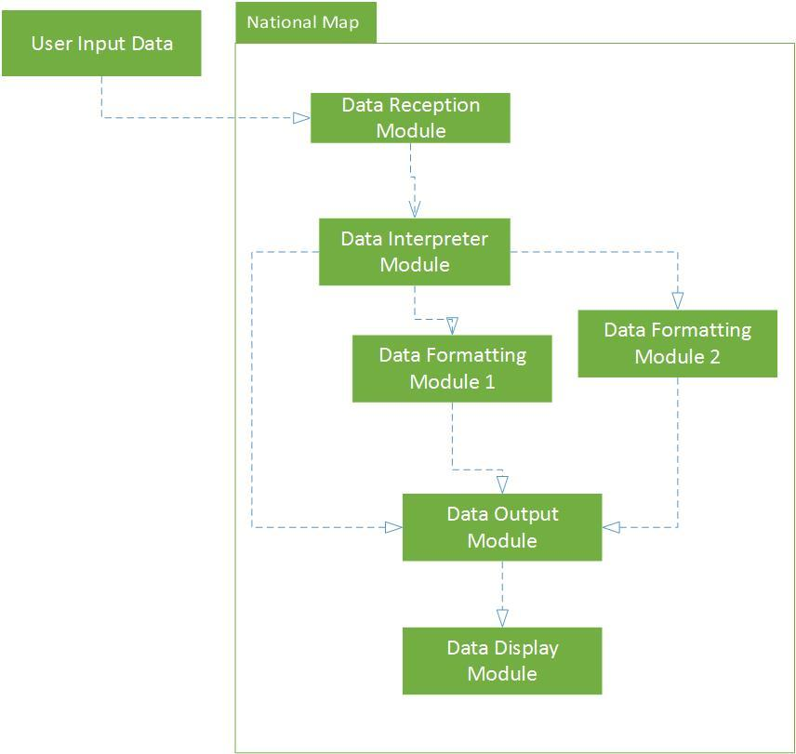

|  |  |
| --- | --- |
| **Component** | **Description** |
| Format Translator - Input Module | Makes sure data to be displayed in National Map is in the appropriate format. Must be able to read input data from multiple formats. |
| Format Translator - Translation Modules | Receives data from the input module. Each output module should only have to deal with translating one possible input data format into the National Map format. |
| Format Translator - Output Module | Receives data from translation modules. Data received from all modules will be in the correct format. This module will act as a universal hub for all data to be displayed, so the call to display data only needs to be written once. |

|  |  |
| --- | --- |
| **Component** | **Related Requirements** |
| Format Translator - All Modules | Sample datasets that utilize formats different from what National Map expects |

**5.4 Activity Diagrams**

We don’t know precisely how our formatting modules will work as of yet, but we will update this document accordingly as we make progress on them.

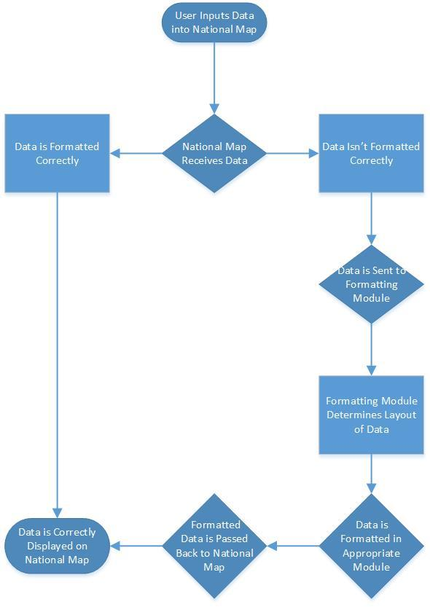

**5.5 Class Diagram**

*This project does not require us to create classes. All existing code we received from our sponsor is written in JavaScript, which does not have any defined “class” structure.

**5.6 Sequence Diagram**

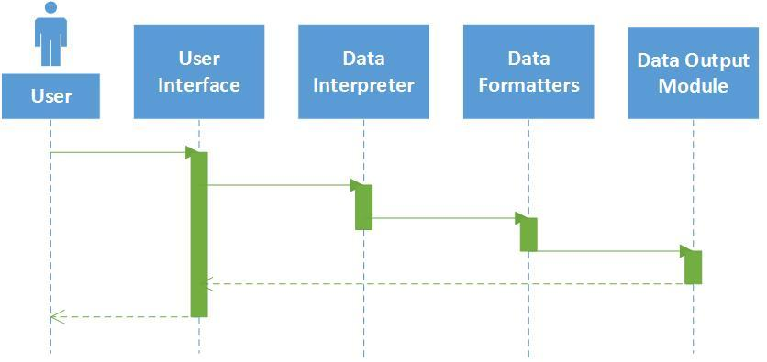

**5.7 Data Architecture**

We have been told by our sponsors that there is a specific format we need to work with, but we are currently not sure what that format is. We have been told to use QGIS (Quantum Geographic Information System, an open-source software tool) for all data translation, as the engineers working on National Map already use it extensively.

We will also be getting in touch with one of the engineers who developed National Map as soon as possible for additional information to determine the required format so we can begin developing our component for National Map.

**5.8 Alternative Designs and Design Rationale**

One alternative we came up with was to have one translation module to do everything. We ultimately decided to go with a multi-module approach instead of a single module to simplify the code we’ll have to write; it will be much easier to debug one of several modules that are each only fifty lines of code than to debug one big module that has all that code and possibly additional logic.

Another design idea was to have a separate console application for formatting data. This design was less ideal because since the general public can upload and apply their own data to the map, each person would have to use the console application beforehand. Integrating the formatting tool directly into the map upon upload allows for a seamless interaction for the general user.

**6. User Interface**

**6.1 UI Description**

<< Provide a brief description of the UI that will be used in this program and how users will interact with the program. >>

**6.2 UI Mockup**

<< Create a mockup of the user interface. This can be a simple drawing that demonstrates key parts of the user interface or a screenshot of a prototype created within an IDE. >>

**7. Test Plan**

**7.1 Test Plan Description**

<< Provide a brief description of how testing will be conducted for this project. >>

**7.2 Testing Tools**

<< Provide a brief description of any testing tools, suites, etc. that will be used to assist with testing the project’s code. >>

|  |  |
| --- | --- |
| **Tool** | **Description / Function** |
| Jenkins | Continuous integration and regression testing. |
|  |  |
|  |  |

**7.3 Test Data**

<< Identify any data that will be necessary as part of the test process. >>

|  |  |  |
| --- | --- | --- |
| **Data** | **Description** | **Link** |
| Sample Data | Sample data of known good and bad examples construct unit tests. | [Link](http://examplelink.com) |
| User Database | Access to company’s Active Directory to test authentication for users. | [Link](http://examplelink.com) |
| Order Database | Stub data for unit tests. | [Link](http://examplelink.com) |

**7.4 Test Types and Frequency**

<< Provide a list of all the different types of tests that will be performed as part of this project, a brief description of each, and the frequency with which each test will be conducted. >>

|  |  |  |
| --- | --- | --- |
| **Type** | **Description** | **Frequency** |
| Integration Test | Integration test of existing code | Weekly starting with Sprint 3 |
| Regression Test | Run unit tests against all code | Daily (2:00 AM) |
| Usability Test | Perform manual usability test of UI. | Every Sprint |

**7.5 Test Coverage**

<< Identify components or other aspects of the project that will not be tested and provide rationale for that reasoning. >>

|  |  |
| --- | --- |
| **Component** | **Rationale** |
| Req. 720 | Do not have sufficient time to generate stub data. |
|  |  |
|  |  |

**7.6 Test Location**

<< Indicate where unit tests, test cases, etc. are being stored >>

**8. Project Closure**

**8.1 Goals / Vision**

**<<** Provide an update to the vision statement that was originally stated in the Project Initiation document. >>

**8.2 Delivered Solution**

<< Provide a high-level description of what was planned and what is being delivered. >>

**8.3 Remaining Work**

<< Provide a short summary of what should be done next, ways of further improving the project, or any additional recommendations. >>

**9. Deliverables**

<< This section contains information on the location of any deliverables for the project. If there are none for a particular category, indicate that it is not applicable. Otherwise provide the name of any files, etc. and where they can be found. >>

**9.1 Study Results**

<< The location of the results of any studies performed as part of this project. >>

**9.2 Requirements and Design Documents**

<< The location of any requirements and design documents. >>

**9.3 Code**

<< The location of any code written for this project. >>

**9.4 Tests and Test Results**

<< The location of any tests (unit, regression, etc.), test results, or other testing documents. >>

**9.5 Build Process Documents**

<< The location of any documents detailing build processes. >>

**9.6 Install Process Documents**

<< The location of any documents describing installation processes. >>

**9.7 Administrator’s and/or User’s Manual**

<< The location of any manuals, or help documentation. >>

**9.8 Postmortem Document**

<< The location of the Postmortem document. >>

**9.9 Final Report**

<< The location of the Final Report document. >>

**10. Definitions and Acronyms**

|  |  |
| --- | --- |
| **Term** | **Definition** |
| NICTA | National Information Communications Technology Australia |
| LGA | Local Government Area |
|  |  |